Experiment No-06
Study of CMOS XOR Gate Schematics in Cadence Virtuoso Software
1.1 Objectives
The main objectives of this experiment are summarized as:
- To understand the concept and operation of a two-input CMOS XOR (exclusive-OR) gate as a fundamental building block of digital logic circuits such as adders and comparators.
- To become familiar with the Cadence Virtuoso schematic editor and the standard IC design flow used to create standard cells.
- To design the transistor-level schematic of a two-input CMOS XOR gate, built as a multi-stage cascade of CMOS inverter, NAND and NOR stages that implements Y = A·B′ + A′·B using eleven PMOS and eleven NMOS devices from the gpdk090 technology library, and to generate its schematic symbol.
- To construct a test bench for the XOR gate, with two independent pulse sources at its two inputs, and verify its functionality through transient simulation using Spectre in the Analog Design Environment (ADE L).
- To obtain and analyze the transient input/output wave-forms of the designed XOR gate for all combinations of its two input signals, and to compare them with the XOR truth table.
Keywords- CMOS XOR gate, NMOS, PMOS, Cadence Virtuoso, schematic editor, Spectre, multi-stage logic, transient response, truth table, standard cell.
1.2 Theory
An XOR (exclusive-OR) gate is a fundamental digital logic gate whose output is HIGH when its two inputs are different. For a two-input XOR gate with inputs A and B and output Y, the operation is expressed by the Boolean expression Y = A ⊕ B = A·B′ + A′·B. The output is HIGH (logic 1) when exactly one of the inputs is HIGH, and LOW (logic 0) when both inputs are LOW or both inputs are HIGH. The truth table of an ideal two-input XOR gate is shown in Table-1.1.
A | B | Y = A ⊕ B
0 | 0 | 0
0 | 1 | 1
1 | 0 | 1
1 | 1 | 0
Table-1.1. Truth table of an ideal two-input XOR gate.
1.2.1 The CMOS XOR Gate (Multi-Stage Implementation)
Unlike the NAND and NOR gates, the XOR function cannot be obtained from a simple pull-up/pull-down pair of series and parallel transistor groups driven by the true inputs alone, because the output depends on whether the inputs differ. A convenient way to build it from the cells of the earlier experiments is to implement the sum-of-products form Y = A·B′ + A′·B directly. The design in this experiment does this with eight CMOS stages: two inverters that generate the complemented inputs A′ and B′ (PM5/NM5 and PM11/NM11); two two-input NAND gates that form ~(A·B′) (PM3, PM4, NM3, NM4) and ~(A′·B) (PM9, PM10, NM9, NM10); two inverters that turn these into the product terms A·B′ and A′·B (PM12/NM12 and PM13/NM13); a two-input NOR gate (PM0, PM1, NM0, NM1) that forms ~(A·B′ + A′·B); and a final inverter (PM2/NM2) that produces the output Vout = A·B′ + A′·B. Each NAND-plus-inverter pair acts as an AND gate and the NOR-plus-inverter pair acts as an OR gate, so the circuit is a cascade of the AND and OR structures studied in the preceding experiments.
For the input combination (A, B) = (1, 0), the product term A·B′ is 1, so the NOR stage output falls LOW and the final inverter drives Vout HIGH; for (0, 1) the product term A′·B is 1 and the output is again HIGH. For (0, 0) and (1, 1) both product terms are 0, the NOR stage output is HIGH, and Vout is LOW. Because none of the stages ever has its pull-up and pull-down networks both fully ON for the same static input combination, the static power dissipation of the overall CMOS XOR gate is ideally zero, just as for the individual inverter, NAND and NOR stages; power is dissipated mainly during switching and through leakage currents.
1.2.2 Transistor Sizing and the Multi-Stage Cascade
The XOR gate of this experiment contains two kinds of transistor stacks: the series NMOS pair in each NAND stage and the series PMOS pair in the NOR stage. Each stack raises the effective resistance of its network compared with a single transistor of the same width and therefore tends to slow the corresponding transition. In addition, the logic depth is larger than for the earlier gates: a change on A passes through up to four stages (NAND, inverter, NOR, inverter), and a change on B or on a complemented input through up to five, so the overall delay from input to output is expected to be correspondingly longer than that of a single stage. The inverter stages restore full-swing, sharply-transitioning signals between the successive stages.
Because the mobility of holes in a PMOS transistor is lower than the mobility of electrons in an NMOS transistor, a PMOS device must be made wider than an NMOS device of the same length to provide comparable drive strength. In this experiment, the same transistor dimensions used for the earlier CMOS inverter, NAND, AND and OR gate designs were retained for all eleven PMOS and all eleven NMOS devices of the XOR gate: every PMOS device was sized with a total width of 720 nm, and every NMOS device with a total width of 240 nm, for the same channel length of 100 nm, giving the same 3:1 PMOS-to-NMOS width ratio as before. Keeping these dimensions unchanged preserves consistency with the earlier experiments, although the transistors in the series stacks were not widened to compensate for the stacking.
1.2.3 Cadence Virtuoso Design Flow
In this experiment, the CMOS XOR gate is designed and verified using the Cadence Virtuoso IC design environment. The overall flow consists of creating a design library attached to a process technology library (gpdk090), drawing the transistor-level schematic in the Schematic XL editor by placing and sizing eleven PMOS and eleven NMOS instances and wiring them into the inverter, NAND, NOR and inverter stages described above, generating a schematic symbol for the XOR cell, and finally building a separate test bench schematic in which the XOR symbol is instantiated along with two independent input sources and supply sources. The test bench is then simulated using the Spectre simulator inside the Analog Design Environment (ADE L) to verify the XOR gate’s transient behaviour.
1.3 Hardware/Software Used for the Experiment
1. Cadence Virtuoso Schematic Editor (Schematic XL)
2. Virtuoso Analog Design Environment (ADE L)
3. Spectre circuit simulator
4. gpdk090 generic process design kit (technology library)
5. Eleven NMOS and eleven PMOS transistors (gpdk090_nmos1v, gpdk090_pmos1v)
6. Two pulse voltage sources (vpulse), a DC voltage source (vdc) and ground (gnd) from analogLib
7. Linux workstation running the Cadence design environment
1.4 Experimental and Simulation Analysis
A design library (XOR_Gate) was created and attached to the gpdk090 technology library, and a schematic cellview (carried over from the earlier inverter template and therefore still internally named inverter) was modified within it to implement the two-input XOR function. Eleven PMOS and eleven NMOS instances were placed in the schematic, sized as described in Section 1.2.2, and wired into the eight stages described in Section 1.2.1, with the input pins A and B, the output pin Vout and the VDD/VSS supply pins. A schematic symbol was then generated for the XOR cell. A separate test schematic (inverter_test) was built in which the XOR symbol was instantiated with two independent pulse sources at its two inputs and a DC supply and ground connected to its power pins, and the design was simulated in ADE L using the Spectre simulator. Each of these steps is illustrated below.
1.4.1 Transistor Sizing and Parameter Selection
The width and length of each transistor were set in the Add Instance window at the time of placement. As in the earlier inverter design, each NMOS transistor was sized with a total width of 240 nm and a channel length of 100 nm, while each PMOS transistor was sized with a total width of 720 nm and the same channel length of 100 nm, giving the 3:1 PMOS-to-NMOS width ratio discussed in Section 1.2.2. The parameter selection window used for setting the NMOS device dimensions is shown in Figure-1.1.
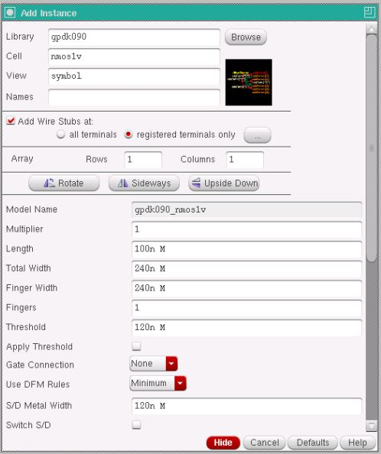
Figure-1.1. Add Instance window showing the width and length parameters set for the NMOS transistor (Total Width = 240n, Length = 100n).
Device | Width (W) | Length (L)
NMOS – NM0–NM5, NM9–NM13 (gpdk090_nmos1v) | 240 nm | 100 nm
PMOS – PM0–PM5, PM9–PM13 (gpdk090_pmos1v) | 720 nm | 100 nm
Table-1.2. Device parameters used for the NMOS and PMOS transistors in the XOR gate schematic.
1.4.2 Transistor-Level Schematic of the CMOS XOR Gate
The schematic of Figure-1.2 is organised into the eight stages described in Section 1.2.1, and the intermediate nets are labelled with their logic function. The two NAND stages (PM3, PM4, NM3, NM4 and PM9, PM10, NM9, NM10) each use two parallel PMOS transistors and two series NMOS transistors and produce the nets ~[A~B] and ~[~AB]. Two further inverters (PM12/NM12 and PM13/NM13) convert these into the product terms [A~B] and [~AB]. The NOR stage (PM0, PM1 in series; NM0, NM1 in parallel) combines the two product terms into the net ~[~AB+A~B], and the final inverter (PM2/NM2) drives the output net labelled [~AB+A~B], which is the Vout pin. The nets A, B, ~A and ~B appear along the left edge of the schematic together with the VDD and VSS rails. The complete transistor-level schematic of the CMOS XOR gate is shown in Figure-1.2.
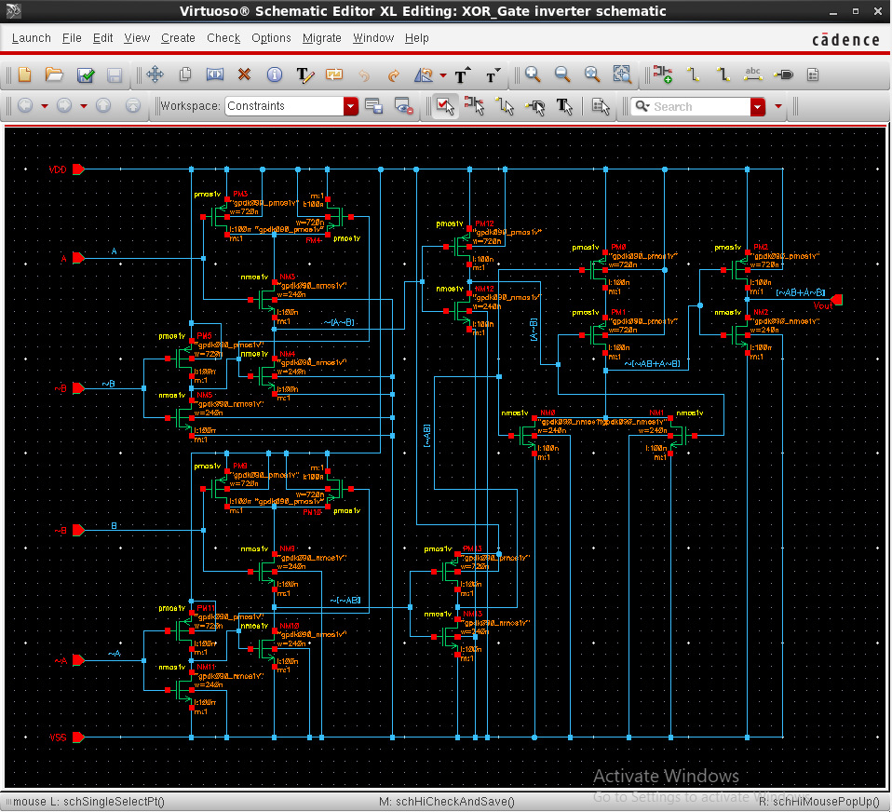
Figure-1.2.1 Complete transistor-level schematic of the CMOS XOR gate (22 transistors), showing the input inverters, the two NAND stages, the two product-term inverters, the NOR stage and the output inverter, with the intermediate nets labelled by their logic function.
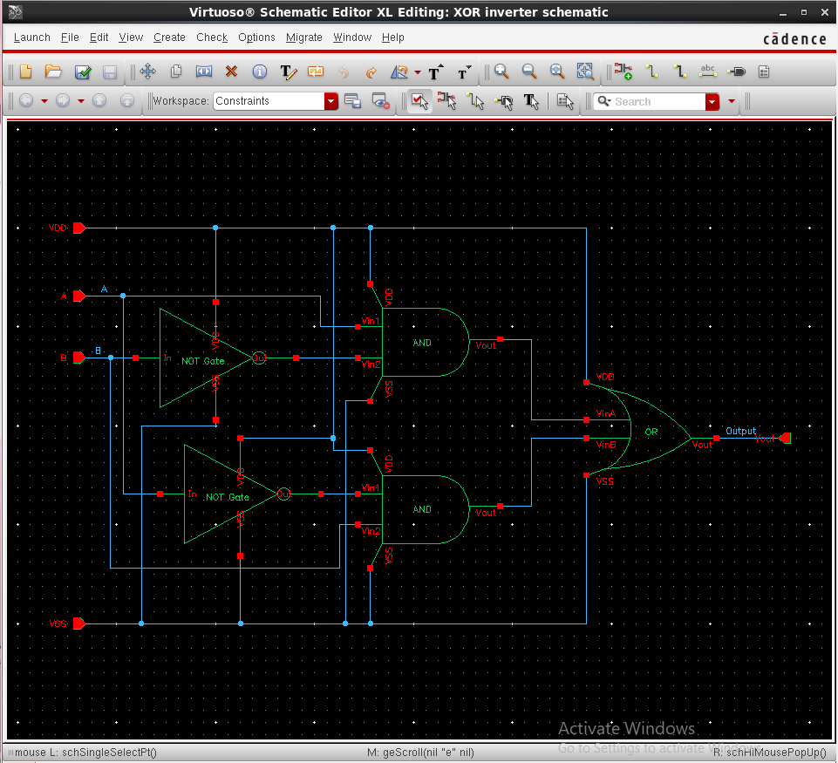
Figure-1.2.2 Complete transistor-level schematic of the CMOS XOR gate in symbol (22 transistors), showing the input inverters, the two NAND stages, the two product-term inverters, the NOR stage and the output inverter, with the intermediate nets labelled by their logic function.

1.4.3 Schematic Symbol Generation
After the schematic was checked and saved without errors, a schematic symbol was generated from the cellview using Create → Cellview → From Cellview, with A and B placed as the two left-side input pins, Vout placed as the right-side output pin, and VDD and VSS placed as the top and bottom pins. The default shape generated by Virtuoso was replaced with the conventional two-input XOR symbol, an OR-gate body with an additional curved line across its input side and no output bubble, with the label XOR placed at its centre, as shown in Figure-1.3.
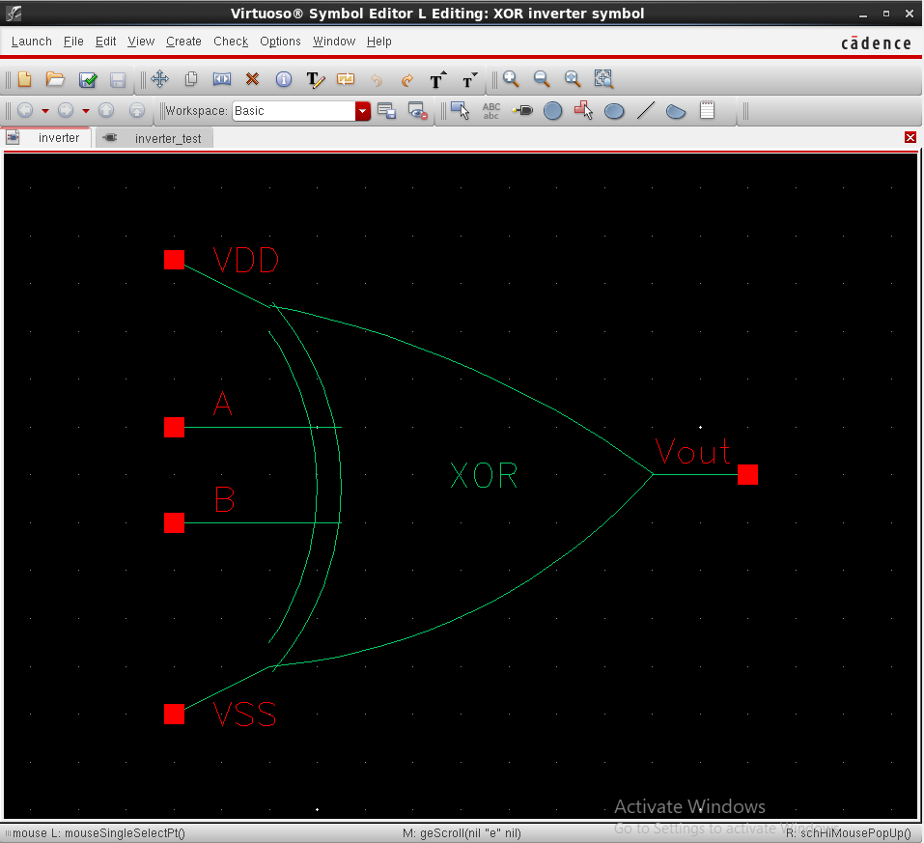
Figure-1.3. Generated schematic symbol of the CMOS XOR gate, showing the two inputs A and B, the output Vout, and the VDD and VSS supply pins.
1.4.4 Test Bench Construction and Source Addition
A separate schematic, inverter_test, was created to verify the XOR gate. The generated XOR symbol was instantiated, and two independent pulse voltage sources (vpulse) from analogLib were connected to its two inputs: source V1 was connected to input A with voltage1 = 0 V, voltage2 = 1.8 V, period = 20 ns and pulse width = 10 ns, while source V2 was connected to input B with voltage1 = 0 V, voltage2 = 1.8 V, period = 40 ns and pulse width = 20 ns, so that all four input combinations of A and B are exercised over the course of the simulation. A DC voltage source (vdc) set to 1.8 V and a ground (gnd) were connected to the VDD and VSS pins respectively, and the input and output nets were named A, B and Output using Create → Wire Name. The completed test bench, with all sources added, is shown in Figure-1.4.
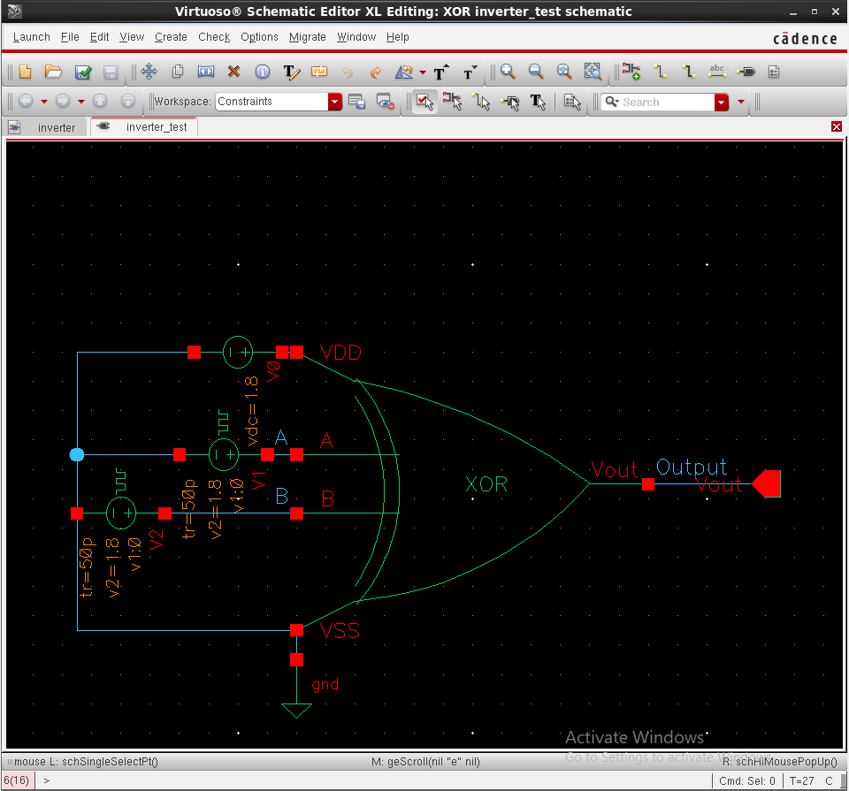
Figure-1.4. Test bench schematic (inverter_test) with the two pulse input sources V1 and V2, the DC supply V0, ground, and the XOR symbol, with the A, B and Output nets labelled.
1.4.5 Input Source Parameter Selection
The Add Instance windows used to configure the two pulse sources and the DC supply are shown in Figure-1.5, Figure-1.6 and Figure-1.7. Figure-1.5 shows the parameters of source V1 driving input A, with Voltage 1 = 0 V, Voltage 2 = 1.8 V, a period of 20 ns, a pulse width of 10 ns, and rise/fall times of 50 ps. Figure-1.6 shows the parameters of source V2 driving input B, configured identically except for a longer period of 40 ns and a pulse width of 20 ns, so that B toggles at half the frequency of A. Figure-1.7 shows the Add Instance window for the vdc source used to set the VDD supply to a DC voltage of 1.8 V.
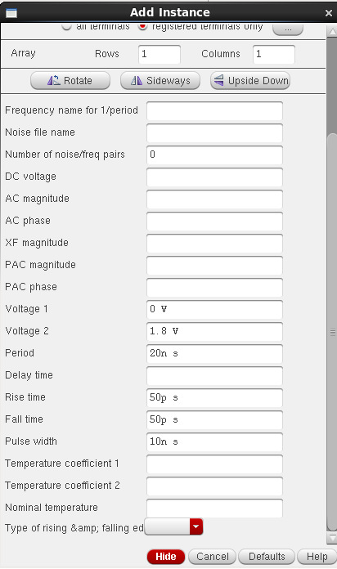 | 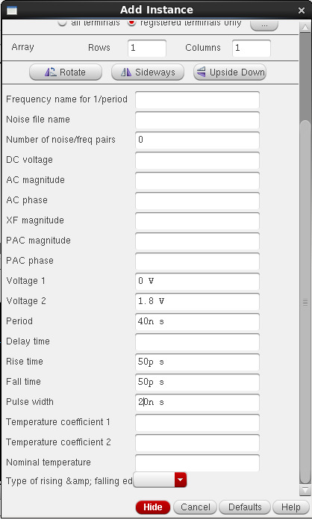
Figure-1.5. Add Instance window showing the pulse source V1 (XOR gate input A): Voltage 1 = 0 V, Voltage 2 = 1.8 V, period = 20 ns, pulse width = 10 ns. | Figure-1.6. Add Instance window showing the pulse source V2 (XOR gate input B): Voltage 1 = 0 V, Voltage 2 = 1.8 V, period = 40 ns, pulse width = 20 ns.
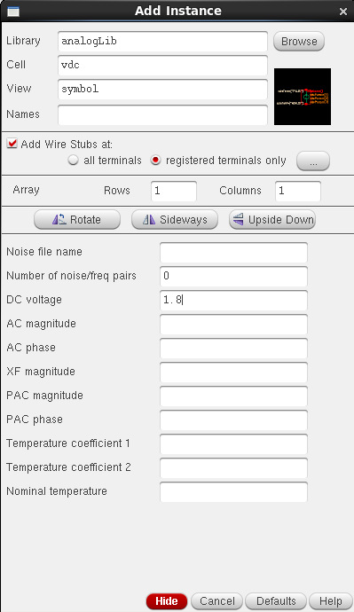
Figure-1.7. Add Instance window showing the vdc source used for the VDD supply, set to a DC voltage of 1.8 V.
1.4.6 Simulation Setup
The test bench was simulated in ADE L using the Spectre simulator, with the gpdk090 Spectre model library added under Setup → Model Libraries. A transient analysis was configured with a stop time of 200 ns so that several cycles of both the 20 ns-period input A and the 40 ns-period input B were captured. The input nets A and B and the output net Output were selected as the outputs to be plotted, and the simulation was run using Simulation → Netlist and Run.
1.4.7 Simulation Results: Input and Output Waveforms
Figure-1.8 shows the simulated transient response of the XOR gate over the first 100 ns of the run. The left-hand plot shows the two pulse inputs, A (top) and B (bottom), each switching between 0 V and 1.8 V, with A having a 20 ns period and a 10 ns pulse width and B having a 40 ns period and a 20 ns pulse width; the right-hand plot shows the corresponding output Vout, plotted as /Output, on the same time axis. In every 40 ns period the inputs step through (A, B) = (1, 1) from 0 to 10 ns, (0, 1) from 10 to 20 ns, (1, 0) from 20 to 30 ns and (0, 0) from 30 to 40 ns. For an ideal XOR gate, Vout should be LOW for (1, 1) and (0, 0) and HIGH for (0, 1) and (1, 0). In the simulation, Vout is LOW from 0 to 10 ns, HIGH from 10 to 40 ns, LOW from 40 to 50 ns, HIGH from 50 to 80 ns, LOW from 80 to 90 ns and HIGH from 90 to 100 ns. The output therefore agrees with the XOR truth table of Table-1.1 for the combinations (1, 1), (0, 1) and (1, 0), but it stays HIGH (about 1.8 V) instead of going LOW during the (0, 0) intervals at 30 to 40 ns and 70 to 80 ns. The trace also starts at about 1.8 V at t = 0, when both inputs are still at their initial 0 V value, and falls to 0 V as the inputs rise, which is consistent with the HIGH level seen for (0, 0). The comparison is summarised in Table-1.3.
Time (ns) | A | B | Expected Vout (XOR) | Observed Vout | Matches XOR?
0 – 10 | 1 | 1 | LOW (0) | LOW (0) | Yes
10 – 20 | 0 | 1 | HIGH (1) | HIGH (1) | Yes
20 – 30 | 1 | 0 | HIGH (1) | HIGH (1) | Yes
30 – 40 | 0 | 0 | LOW (0) | HIGH (1) | No
Table-1.3. Input levels and output levels read from the waveforms of Figure-1.8 for the first 40 ns period, compared with the ideal XOR output. The same four intervals repeat every 40 ns: Vout is again LOW from 40 to 50 ns and from 80 to 90 ns (A = B = 1) and again HIGH instead of LOW from 70 to 80 ns (A = B = 0).
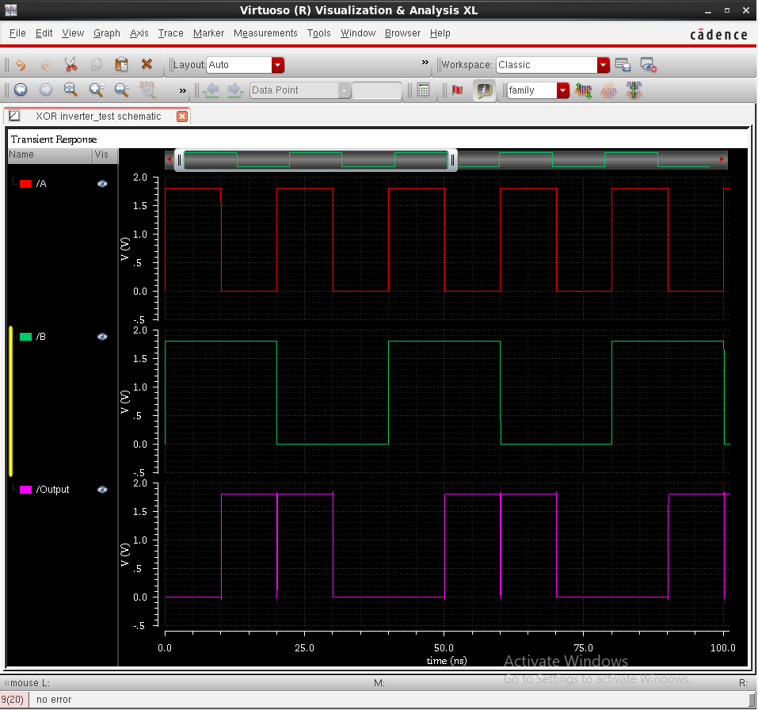
Figure-1.8. Simulation results: the two pulse inputs A and B (left) and the corresponding output Vout, plotted as /Output (right), over 0 to 100 ns.
1.5 Discussion
The simulated behaviour of the designed circuit agreed with the theoretical XOR operation described in Section 1.2 for three of the four input combinations. Vout went LOW when both inputs were HIGH (0 to 10 ns, 40 to 50 ns and 80 to 90 ns) and HIGH when exactly one input was HIGH (10 to 30 ns, 50 to 70 ns and 90 to 100 ns). For the fourth combination, (A, B) = (0, 0), however, Vout stayed HIGH (30 to 40 ns and 70 to 80 ns) where an ideal XOR gate gives LOW, so over the observed window the output coincided with that of a NAND gate rather than an XOR gate, and the truth table of Table-1.1 was not fully reproduced in this run. Because the XOR function relies on correctly formed complemented inputs A′ and B′, the first place to check is the complemented-input path of the schematic (the inverters PM5/NM5 and PM11/NM11 and the nets labelled ~A and ~B), after which the simulation should be repeated. The same 720 nm / 240 nm / 100 nm transistor dimensions as in the earlier gate experiments were used for all 22 devices; the series stacks in the NAND and NOR stages and the depth of up to five stages are expected to make the gate slower than a single-stage gate, although propagation delay was not measured in this experiment.
1.6 Conclusion
In this experiment, a two-input CMOS XOR gate was designed at the transistor level in Cadence Virtuoso as a cascade of eight CMOS stages (input inverters, two NAND stages, two product-term inverters, a NOR stage and an output inverter) using eleven PMOS and eleven NMOS devices from the gpdk090 technology library, and its schematic symbol was generated. A test bench was constructed with two independent pulse sources at the two inputs and a DC supply, and the circuit was simulated using Spectre in ADE L. The observed waveforms showed the expected output for the input combinations (1, 1), (0, 1) and (1, 0), but the output remained HIGH for (0, 0) instead of going LOW, so the XOR function was not fully verified in this run and the complemented-input path of the schematic should be re-checked and the simulation repeated. The experiment nevertheless provided practical, hands-on experience with building a composite standard cell from several cascaded logic stages, which forms the basis for more complex digital and mixed-signal IC design in subsequent experiments.

